**A satellite-based ice fraction record for small water bodies of the Arctic Coastal Plain**

Hong Lin, Jinyang Du, John S. Kimball

NTSG, University of Montana

Contact: [jinyang.du@ntsg.umt.edu](mailto:jinyang.du@ntsg.umt.edu)

August 15, 2025

# Dataset summary

|  |  |
| --- | --- |
| Period | 2017–2023 |
| Temporal resolution | ~6 days |
| Spatial resolution | 1 km |
| Projection | Alaska Albers Equal Area projection (EPSG: 3338) |
| Data format | GeoTIFF |

# Dataset description

The ice fraction dataset records the fractional ice cover of small water bodies (900 m² to 25 km²) within each 1-km grid cell in the Arctic Coastal Plain of Alaska (ACP) from 2017 to 2023, with a temporal resolution of about 6 days. The 1-km ice fraction was aggregated from 10-m ice cover maps. The 10-m maps were generated using random forest classification models based on Sentinel-1 SAR imagery, texture features, and temperature data. For more details, please refer to the paper.

Temporal resolution is defined as the time interval between consecutive observations for a given 1-km grid cell. The temporal resolution of this dataset varies across different regions of the ACP due to differences in Sentinel-1 mission observation coverage. The figure below shows the temporal resolution of the dataset.

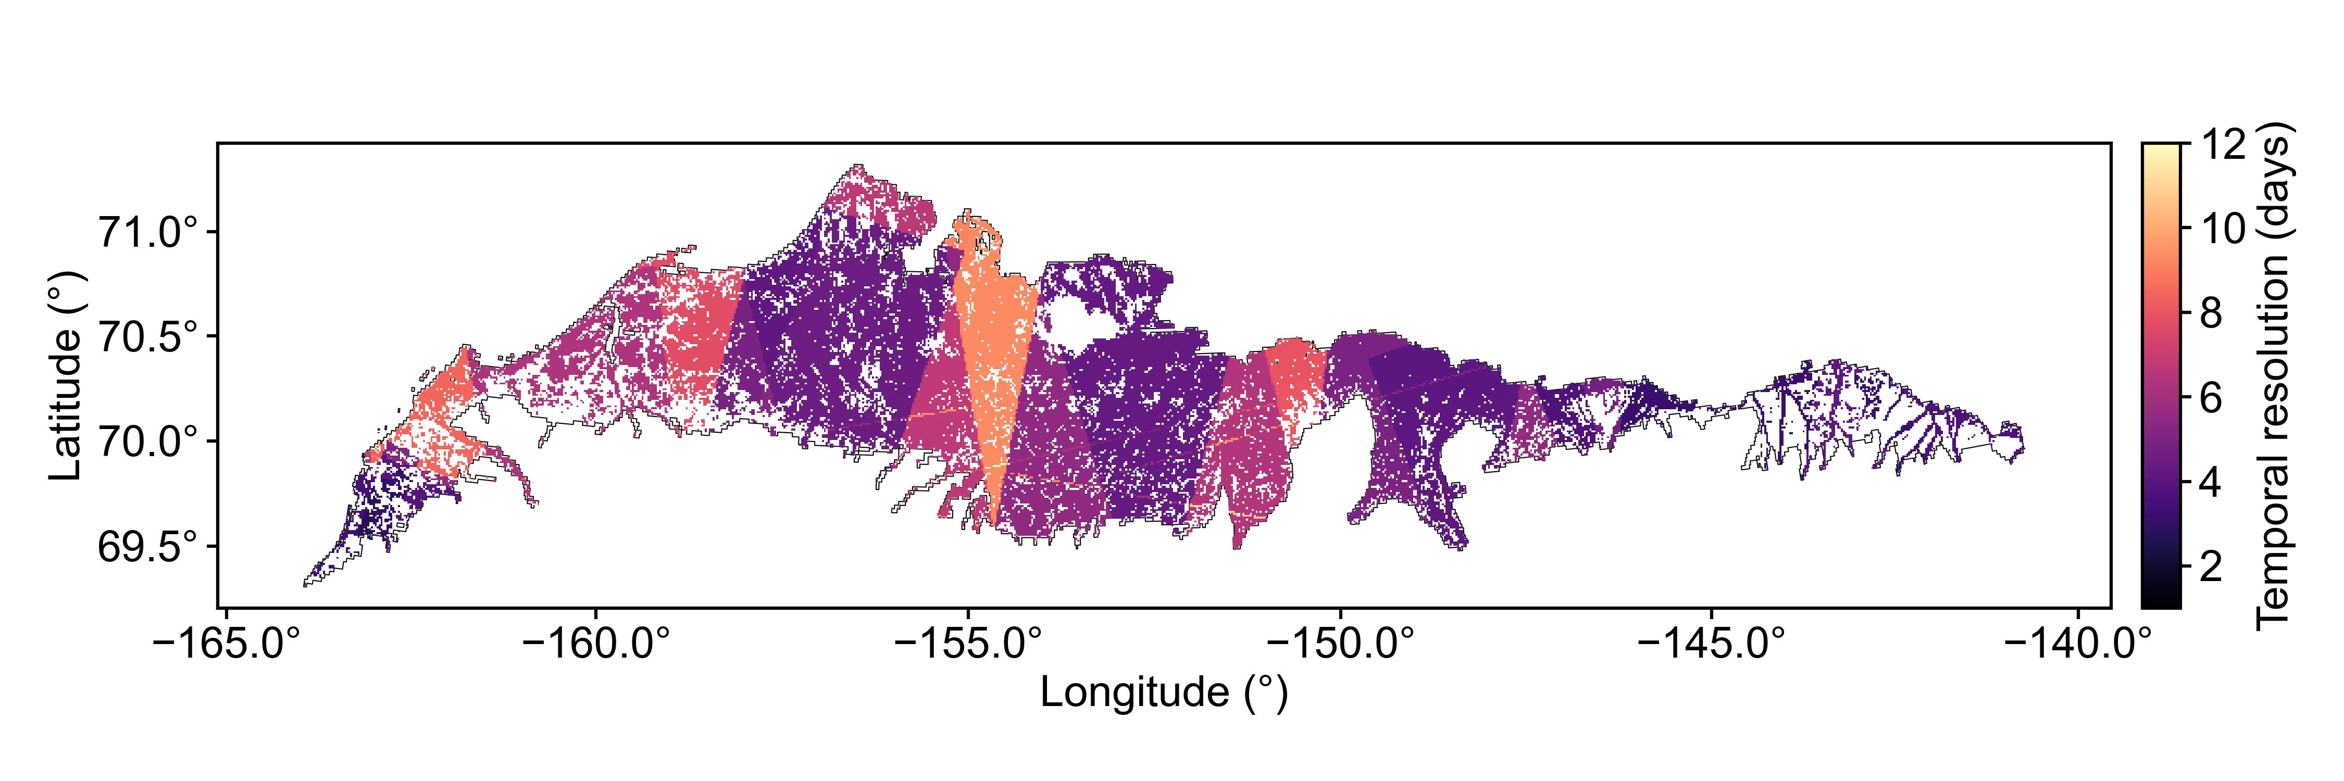

# Data format

The ice fraction dataset consists of a collection of GeoTIFF images named as YYYYMMDD.tif. Each GeoTIFF represents the ice fraction of small water bodies in the ACP on a given day, observed by both ascending and descending Sentinel-1 passes. Each GeoTIFF image contains the following two bands:

|  |  |  |  |
| --- | --- | --- | --- |
| Name | Data type | Value range | Description |
| ice | float32 | [0, 1] | Ice fraction of 1-km grid cell |
| swb | float32 | (0, 1] | Small water body proportion in 1-km grid cell |

# Quality layer

The quality layer represents the data quality of ice fraction for each 1-km grid cell, calculated using Relative Root Mean Square Error (RRMSE), with a spatial resolution of 1 km. The quality layer contains a single band named “RRMSE” with a data type of float32.