**Rain-on-Snow Frequency and Distribution during Cold Seasons, Alaska, 2002-2023 and 1988-2020**

**Summary**

This dataset provides maps of rain-on-snow (ROS) events across Alaska for the individual months from November to March using the respective observations from two sets of space-borne passive microwave radiometers: (a) the Advanced Microwave Scanning Radiometer for EOS and Advanced Microwave Scanning Radiometer 2 (AMSR-E/2) from 2002 to 2023; and (b) the Special Sensor Microwave Imager and the Special Sensor Microwave Imager Sounder (SSMI/S) from 1988 to 2020. ROS events were defined as changes in surface snow wetness and isothermal states induced by atmospheric processes often associated with winter rainfall. The data are summations of the number of days with ROS events per pixel at 6-km spatial resolution per month or per 5-month water year. The daily ROS record encompassed the months when snowmelt from solar illumination is minimal and snow cover is widespread and relatively consistent throughout the region.

For the AMSR-E/2-based record, daily ROS geospatial classification across Alaska was derived by combining snow cover and daily microwave brightness temperature (Tb) retrievals from overlapping (a) Moderate Resolution Imaging Spectroradiometer (MODIS) MOD10A2 eight-day maximum snow cover extent (SCE) product and (b) AMSR-E (2002-2011) and AMSR2 (2012-2023) observations. For the SSMI/S-based record, ROS classification was made using (a) Tb observations from SSM/I F08 (1988-1991), F11 (1992-1995), F13 (1996-2007), SSMIS F17 (2007-2016) and F18 (2016-2020), and (b) snow simulations from a snow-evolution modeling system SnowModel (Liston et al., 2006).

ROS events were detected using a spectral gradient ratio approach to exploit the 19 and 37 GHz dielectric properties in response to enhanced liquid water content (LWC) within the surface snowpack. The spectral gradient ratio was applied to vertical and horizontal polarizations for constructing the gradient ratio polarization (GRP). ROS events were identified if the associated GRP values were smaller than predefined thresholds. The threshold was set as 1 for pixels with elevation below 900 m and -5 for higher elevations. To minimize potential misclassifications between ROS and persistent wet-snow conditions not caused by rainfall, an additional algorithm constraint was applied by requiring no ROS detected on the day prior to an identified ROS event (Pan et al., 2019).

For AMSR-E/2 record, there are 120 data files in GeoTIFF (.tif) format with this dataset. This includes data for the 100 months of November - March 2002-2011 and November - March 2012-2023, and 20 water year summary maps for 2003-2011 and 2013-2023. There are no data for the water year 2012 (November 2011 - March 2012). For SSMI/S record, there are 192 data files in GeoTIFF (.tif) format with this dataset. This includes data for the 160 months of November - March 1988-2020, and 32 water year summary maps for 1988-2020. These files provide the number of days per pixel associated with ROS events in ABoVE grid tiles.

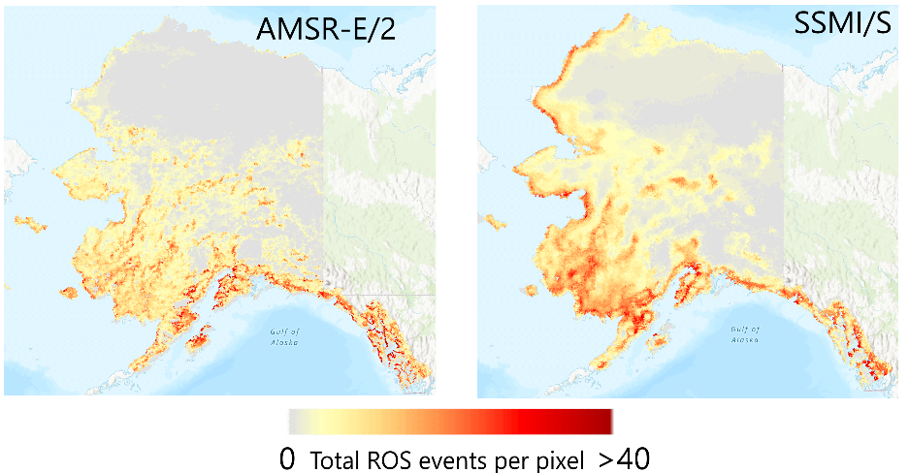

Figure 1. Total numbers of rain-on-snow (ROS) events per 6-km pixel over Alaska for water year 2014, which were derived using the respective AMSR-E/2 (left) and SSMI/S (right) observations.

**Citation**

Pan C. G., J. Du, P.B. Kirchner, and J.S. Kimball. 2025. ABoVE: Rain-on-Snow Frequency and Distribution during Cold Seasons, Alaska, 2002-2023 and 1988-2020. ORNL DAAC, Oak Ridge, Tennessee, SA.

1. **Data Set Overview**

The dataset provides maps of rain-on-snow (ROS) events across Alaska for the individual months from November to March using the respective observations from two sets of space-borne passive microwave radiometers: (a) the Advanced Microwave Scanning Radiometer for EOS and Advanced Microwave Scanning Radiometer 2 (AMSR-E/2) from 2002 to 2023; and (b) the Special Sensor Microwave Imager and the Special Sensor Microwave Imager Sounder (SSMI/S) from 1988 to 2020. ROS events were defined as changes in surface snow wetness and isothermal states induced by atmospheric processes often associated with winter rainfall. The data are summations of the number of days with ROS events per pixel at 6-km spatial resolution per month or per 5-month water year. The daily ROS record encompassed the months when snowmelt from solar irradiance is minimal and snow cover is widespread and relatively consistent throughout the region.

For the AMSR-E/2-based record, daily ROS geospatial classification across Alaska was derived by combining snow cover and daily microwave brightness temperature (Tb) retrievals from overlapping (a) Moderate Resolution Imaging Spectroradiometer (MODIS) MOD10A2 eight-day maximum snow cover extent (SCE) product and (b) AMSR-E (2002-2011) and AMSR2 (2012-2023) observations. For the SSMI/S-based record, ROS classification was made using (a) enhanced-resolution Tb observations (Brodzik and Long, 2018) from SSM/I F08 (1988-1991), F11 (1992-1995), F13 (1996-2007), SSMIS F17 (2007-2016) and F18 (2016-2020), and (b) snow cover simulations from a snow-evolution modeling system SnowModel (Liston et al., 2023).

ROS events were detected using a spectral gradient ratio approach to exploit the 19 and 37 GHz dielectric properties in response to enhanced liquid water content (LWC) within the surface snowpack. The spectral gradient ratio was applied to vertical and horizontal polarizations for constructing the gradient ratio polarization (GRP). ROS events were identified if the associated GRP values were smaller than predefined thresholds. The threshold was set as 1 for pixels with elevation below 900 m and -5 for higher elevations. To minimize potential misclassifications between ROS and persistent wet-snow conditions not caused by rainfall, an additional algorithm constraint was applied by requiring no ROS detected on the day prior to an identified ROS event (Pan et al., 2019) (refer to Figure 2 for a diagram of the workflow).

**Project:** [Arctic-Boreal Vulnerability Experiment](https://daac.ornl.gov/ABOVE/above.shtml)

The Arctic-Boreal Vulnerability Experiment (ABoVE) is a NASA Terrestrial Ecology Program field campaign based in Alaska and western Canada between 2016 and 2025. Research for ABoVE links field-based, process-level studies with geospatial data products derived from airborne and satellite sensors, providing a foundation for improving the analysis and modeling capabilities needed to understand and predict ecosystem responses and societal implications.

**Related Publication:**

Pan, C.G., P.B. Kirchner, J.S. Kimball, Y. Kim, and J. Du. 2018. Rain-on-snow events in Alaska, their frequency and distribution from satellite observations. Environ. Res. Lett., (13),7. <https://doi.org/10.1088/1748-9326/aac9d3>

Pan, C.G., J.S. Kimball, M. Munkhjargal, N.P. Robinson, E. Tijdeman, L. Menzel and P.B. Kirchner, 2019. Role of surface melt and icing events in livestock mortality across Mongolia’s semi-arid landscape. Remote Sensing, 11(20), p.2392.

Du, J., P.B. Kirchner, C. G. Pan, J. D. Watts, J.S. Kimball. 2025. Assessing rain-on-snow event dynamics over Alaska using 30-year satellite microwave observations. Environ. Res. Lett., (in review)

**Acknowledgments:**

This research was funded by the National Park Service, Southwest Alaska Inventory and Monitoring Network (P23AC01622-00) and the National Aeronautics and Space Administration (80NSSC22K1238).

1. **Data Characteristics**

**Spatial Coverage** Alaska

**ABoVE Reference Locations:**

**Domain:** Core ABoVE

**Grid cells:** Ah000-001v000-001

**Spatial resolution:** 6 km

**Temporal coverage:** 1988-11-01 through 2023-03-31.

**Temporal resolution:** Monthly and by Water Year

**Study Areas**(All latitude and longitude given in decimal degrees)

| **Site** | **Westernmost Longitude** | **Easternmost Longitude** | **Northernmost Latitude** | **Southernmost Latitude** |
| --- | --- | --- | --- | --- |
| Alaska, USA | -175.3897222 | -111.5422222 | 73.84722222 | 48.62694444 |

**File information**

For AMSR-E/2 record, there are 120 data files in GeoTIFF (.tif) format with this dataset. This includes data for the 100 months of November - March 2002-2011 and November - March 2012-2023, and 20 water year summary maps for 2003-2011 and 2013-2023. There are no data for the water year 2012 (November 2011 - March 2012). For SSMI/S record, there are 192 data files in GeoTIFF (.tif) format with this dataset. This includes data for the 160 months of November - March 1988-2020, and 32 water year summary maps for 1988-2020. These files provide the number of days per pixel associated with ROS events in ABoVE grid tiles.

**Data file naming conventions:**

The monthly files are named **ABoVE_{sensor}_{year}_M{month}A_All.tif**

where **sensor** is either “SSMI” (referring to SSMI/S sensors) or “AMSRU” (referring to AMSR-E/2 sensors), **year**is calendar year (YYYY) and **month**(format mm) is the month over which the summation occurred.

 The water-year files are named**ABoVE_{sensor}_{year}_WY_A_All.tif**

where **sensor** is either “SSMI” (referring to SSMI/S sensors) or “AMSRU” (referring to AMSR-E/2 sensors),and **year**is water year (YYYY) over which the summation occurred. That is, water year 2003 begins in November 2002 and ends in March of 2003.

**Example file names:**

Monthly:  ABoVE_AMSRU_2003_M11A_All.tif

Water year:  ABoVE_SSMI_1989_WY_A_All.tif

**Table 1.**  Description of data values in the files.

| **Value** | **Description** |
| --- | --- |
| 0-133 | The range, minimum to maximum, of the number of days where ROS/wet snow was observed across the AK domain (total ROS events per pixel). No rain-on-snow identified=0 |
| -9999 | Masked values outside of the AK domain (no data value) |

**Properties of the GeoTIFF files**

* Map units- meters.
* Variable units- days (number of days of snow-on-rain events per pixel).
* Native data type- Int16
* Projection-EPSG: 102001 (standard ABoVE projection)

1. **Application and Derivation**

Much of Alaska is in the ABoVE domain, where a better understanding of the distribution and underlying drivers of ROS will contribute to the ABoVE science objectives. The resulting data record for ROS events is suitable for documenting the spatial-temporal impacts of ROS events to changes in ecosystem services, wildlife populations, and hydrologic processes across Alaska (Pan et al., 2018).

1. **Quality Assessment**

A two-tiered validation approach was used to determine the accuracy of ROS detection. Tier-one combined human observer and meteorological measurements from Fairbanks, Alaska and resulted in estimated annual ROS detection accuracies from 75-100%. The tier-two validation filtered satellite detected snow wetness using three temperature derived proxies from 53 meteorological stations across Alaska. These proxies included the ratio between dew point and average temperature, wet bulb temperature, and the maximum and minimum temperature ratio, and produced a relative accuracy of 86% (Pan et al., 2018).

1. **Data Acquisition, Materials, and Methods**

Wet snow and the icing events that frequently follow wintertime rain-on-snow (ROS) affect high latitude ecosystems at multiple spatial and temporal scales, including hydrology, carbon cycle, wildlife, and human development.  In this study, ROS spatio-temporal variability was quantified across Alaska during the cold season, for the individual months from November to March, and the associated water year summaries.

ROS days were defined as the satellite passive microwave detection of abrupt changes in surface snow wetness and isothermal states induced by physical processes, such as sensible, latent and turbulent heat exchange that are often associated with winter rainfall. ROS events and associated snow wetness were detected using a spectral Gradient Ratio to exploit the 19 and 37 GHz dielectric properties in response to ROS events and enhanced liquid water content (LWC) within the surface snowpack (Grenfell and Putkonen, 2008).

Data sources used in the study included:

* The AMSR-E sensor, launched in 2002 on board the NASA Aqua satellite, and operated until 2011,
* The AMSR2, successfully launched in 2012 on board the JAXA GCOM-W satellite,
* Observations (1988-2020) from the SSMI/S sensors on board the Defense Meteorological Satellite Program (DMSP) satellites,
* The MOD10A2 eight-day maximum snow cover extent (SCE) product (2002-2023) (Hall and Riggs, 2016), and
* Snow cover simulations (1988-2020) from a snow-evolution modeling system SnowModel.

**ROS workflow**

The Alaska regional classification was derived using daily ascending V and H *pol* *Tb* retrievals at 19 and 37 GHz from the 6-km resolution polar EASE-grid v2 AMSR-E/2 and SSMI/S record. Two different GRP thresholds were applied to classify ROS events for different elevation zones: GRP < 1 was used to identify ROS events below 900 m, while GRP <−5 was used for elevations above 900 m (Figure 2). The ROS algorithm was performed over the snow-covered pixels, which were determined by 37 GHz V *pol* *Tb* (*Tb* < 265 K), ancillary MODIS snow cover extent (SCE) product in the AMSR-E/2-based retrievals, and SnowModel snow cover simulations in the SSMI/S-based retrievals.

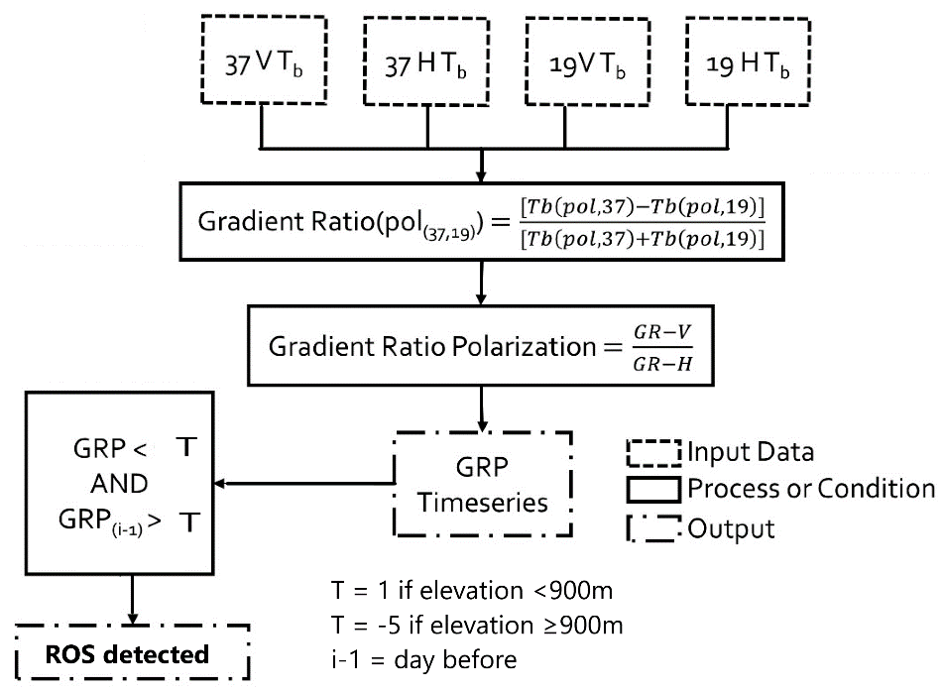

Figure 2. Schematic of workflow used to derive ROS product (Pan et al., 2018; Pan et al., 2019).

1. **Data Access**

These data are available through the Oak Ridge National Laboratory (ORNL) Distributed Active Archive Center (DAAC).

[ABoVE: Rain-on-Snow Frequency and Distribution during Cold Seasons, Alaska, 2002-2023 and 1988-2020](https://daac.ornl.gov/cgi-bin/dsviewer.pl?ds_id=1611)

Contact for Data Center Access Information:

* E-mail: [uso@daac.ornl.gov](mailto:uso@daac.ornl.gov)
* Telephone: +1 (865) 241-3952

1. **References**

Brodzik, M. J. and D. G. Long. 2018. Calibrated Passive Microwave Daily EASE-Grid 2.0 Brightness Temperature ESDR (CETB) Algorithm Theoretical Basis Document, v1.0. NSIDC MEaSUREs Project White Paper. NSIDC. Boulder, CO, USA. doi: 10.5281/zenodo.7958456.

Du, J., P.B. Kirchner, C. G. Pan, J. D. Watts, J.S. Kimball. 2025. Assessing rain-on-snow event dynamics over Alaska using 30-year satellite microwave observations. Environ. Res. Lett., (in review)

Grenfell, T.C. and J. Putkonen. 2008. A method for the detection of the severe rain-on-snow event on Banks Island, October 2003, using passive microwave remote sensing Water Resour. Res. 44 1–9. <https://doi.org/10.1029/2007WR005929>

Hall, D. K. and G. A. Riggs. 2016. MODIS/Terra Snow Cover 8-Day L3 Global 500m Grid, Version 6. Boulder, Colorado USA. NASA National Snow and Ice Data Center Distributed Active Archive Center. <https://doi.org/10.5067/MODIS/MOD10A2.006>. [June 16, 2017].

Homer, C., J. Dewitz, L. Yang, S. Jin, P. Danielson, G. Xian, J. Coulston, N. Herold, J. Wickham, and K. Megown. 2015. Completion of the 2011 National Land Cover Database for the Conterminous United States – Representing a Decade of Land Cover Change Information.  Photogrammetric Engineering and Remote Sensing. American Society for Photogrammetry and Remote Sensing, Bethesda, MD, 81:345-354

Liston, G.E., A.K. Reinking, and N.T. Boleman. 2023. Daily SnowModel Outputs Covering the ABoVE Core Domain, 3-km Resolution, 1980-2020. ORNL DAAC, Oak Ridge, Tennessee, USA. https://doi.org/10.3334/ORNLDAAC/2105

Pan, C.G., P.B. Kirchner, J.S. Kimball, Y. Kim, and J. Du. 2018. Rain-on-snow events in Alaska, their frequency and distribution from satellite observations. Environ. Res. Lett., 7. <https://doi.org/10.1088/1748-9326/aac9d3>

Pan, C.G., J.S. Kimball, M. Munkhjargal, N.P. Robinson, E. Tijdeman, L. Menzel and P.B. Kirchner, 2019. Role of surface melt and icing events in livestock mortality across Mongolia’s semi-arid landscape. Remote Sensing, 11(20), p.2392.