FOR 240 Class Notes – Genetics and Reproduction

Tree Genetics (from: Forest Ecology by Barnes et al., 1998)

There are 2 primary influences on an organism’s development:
1 – genotype
2 – environment

The genotype is the genetic makeup of an individual plant. We will never see the true genotype because a plant is influenced by its environment from the moment of fertilization. The resulting influence of both genotype (Vg) and environment (Ve) is termed the phenotype. This influence varies, and is not necessarily 50-50. The strength of genetic control is called heritability and is determined by the ratio of the genetic variance to the total phenotypic variance (Vt),

heritability = Vg / (Vg + Ve) = Vg / Vt

In other words, heritability is the ability of a character (e.g., height) to be passed on to the next generation, or the extent to which an attribute is under genetic control. Strong genetic control has been shown for such things as stem straightness, date of bud burst, and susceptibility to leaf rusts. Traits with less genetic control (and, thus, more environmental control) include tree height and stand density. Environment includes more than just the climatology of an area. Such things as soil water and nutrient availability, pollution, and elevation must be considered.

As a result, a given genotype may exhibit different phenotypes in different environments. This plasticity of phenotype is defined as the degree to which a character within a given genotype can be modified by environmental conditions.

Some plastic characteristics include: | Some non-plastic characteristics are:
Size of vegetative parts | Leaf shape
Number of shoots, leaves, flowers | Serration of leaf margin
Elongation rate of stems | Floral characteristics
Photoperiodism

In general, characteristics, created over long periods of growth (e.g., stem elongation) are more affected by environment and tend to be more plastic than those created rapidly (e.g., reproductive structures, leaf shape).

There are a number of ways in which a genotype can vary. First, there is gene flow between populations, especially in the animal kingdom. Another possibility is geographic isolation, in which the gene pool becomes less and less diverse. Finally, there is the mutation and recombination of genes, which is the primary method of genetic variation within plants. Genetic variation of any type is important for species survival and is a major advantage of sexual reproduction. If a plant is unable to adapt to a given change, it may cease to exist in that area.

All of this leads to the concept of a niche. A niche is the where, when, and how a species is genetically adapted to persist. Some organisms have very narrow niches (specialists), while others have broader niches (generalists). Merriam-Webster defines a niche as “a habitat supplying the factors necessary for the existence of an organism or species” or “the ecological role of an organism in a community especially in regard to food consumption”.
There are three components to the definition of a niche:
Where: spatial component. Where is this species able to exist? Is this species largely
found in the southern U.S. (e.g., Loblolly pine) or the northern U.S. (e.g.,
Douglas fir)? Does it exist only in floodplains (e.g., cottonwoods) or in
drier areas (juniper)? How dependent is this species on a given set of
conditions?
When: temporal component. When does this species dominate at a given site? Is it
found at the site early in succession (e.g., birch, lodgepole pine) , or is it a
species which is found only after a site has been under development for
some time (e.g., hemlock)?
How: functional (physiological) component. How do they reproduce? What is their
growth rate? What is the tolerance of this species to disturbance (fire, flood, shade, drought, etc.)?

Figure 5.2 Tree Regeneration (from: Forest Ecology by Barnes et al., 1998)
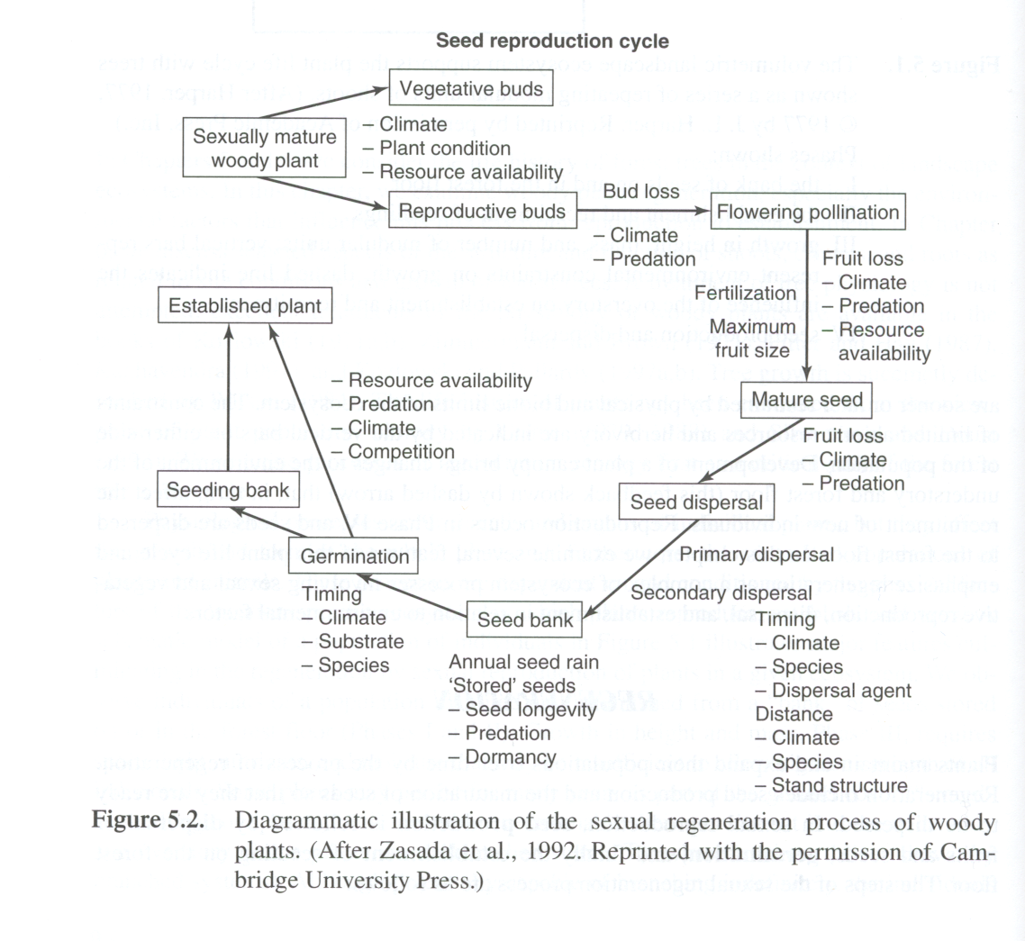
Regeneration includes the production and maturation of seeds. In sexual reproduction, one may find species that have both male and female flowers on a single tree (monoecious) or on different trees (dioecious). Self-pollination usually leads to reduced growth, and these seedlings are often eliminated through competition, although they are quite important after fire. Angiosperms rarely produce viable self-pollinated seeds, while conifers (especially pines) are more likely to produce viable self-pollinated seeds. Pollination occurs via wind and insects. Wind-pollinated species (aspen, birch, elm) flower in early spring before leaves flush-out (Why?). Insect-pollinated species will flower as leaves are flushing. Conifers are exclusively wind-pollinated, and female cone buds are found in the top third of the crown. This increases the chances of cross-pollination.

Cross-pollination leads to genetic variability and the ability of a species to respond to environmental cues such as climate change. There are two ways in which angiosperms, predominately cross-pollinators, avoid self-pollination: spatial separation and temporal separation. Spatial separation includes the plant having both male and female flowers, which can even be in different locations on the branch or plant (e.g., birch). The ratio of male to female flowers is not necessarily 50-50. Some trees may contain predominately male flowers and some predominately female flowers. Additionally, there are species which contain male and female plants, resulting in true cross-pollination (e.g., willows, poplar). Temporal separation is just that: The pollen will be released and several days later, the stigma will open…or vice versa (this is species specific; e.g., pecan, walnut). Each flower contains both the stamen and the pistils, so without temporal separation, self-pollination would be likely to occur. With temporal separation, the pollen will have already been removed from the area, there is less chance of self-pollination. Some plants exhibit self-incompatibility – the plant recognizes that self-fertilization has occurred and aborts the process.

(1) Seed production is followed by (2) dispersal of fruit and seeds by gravity, wind, water and/or animals. Seed dispersal is followed by (3) seed germination, and finally, (4) seedling establishment. Between dispersal and germination, seeds are stored in a seedbank, which may be active or dormant. An active seedbank requires no dormancy and seeds will germinate as soon as conditions are favorable (e.g., aspens, cottonwoods, many pines). Many of these seeds are short-lived. Dormant seed banks require a dormancy period (often winter). Therefore, although seeds are dispersed during the fall, they lie dormant over the winter and germinate the following spring. Some seeds may be adapted for a specific type of dormancy period. For example, some seeds require a certain cold temperature in order to germinate; others require fire. Seeds in a dormant seedbank may remain dormant and viable for many years, waiting for better conditions to occur (e.g., elderberry). Whether active or dormant, unless the required conditions are met, germination will not occur.

Asexual reproduction may also occur. During asexual (or vegetative) reproduction, a parent plant will create new vegetative shoots which will eventually establish themselves as fully functional, independent clones of the parent. These vegetative shoots can arise from
(1) the basal stem - where the stem joins the root (oak, hickory, alder, birch);
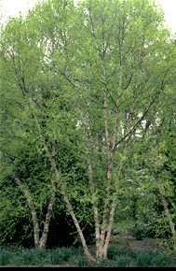
(2) the roots (aspen, beech, sweetgum);
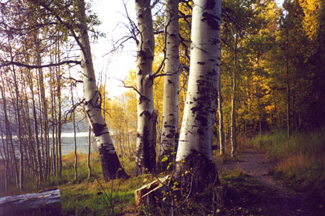
(3) the rhizome - horizontal underground stems (many shrubs, dogwood, striped maple); 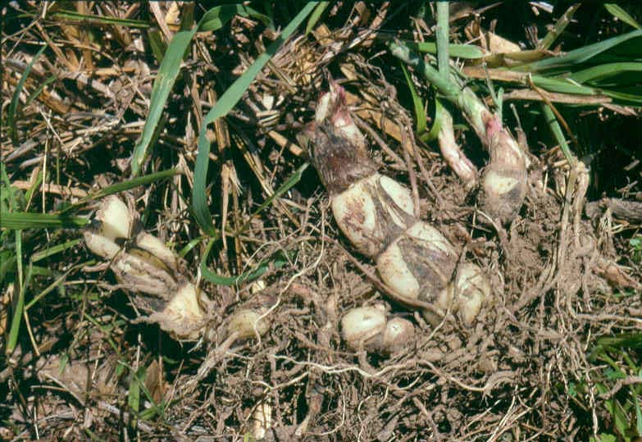
(4) the lignotuber - a buried starchy mass of stem tissue (eucalypts);
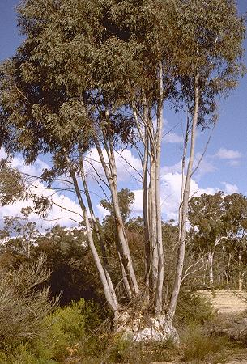
(5) stolons - arching branches that take root after coming in contact with the soil surface
(dogwood)
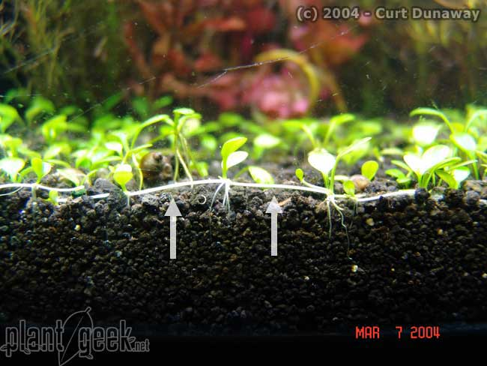
(7) fragmentation - a branch breaks off, is buried and becomes established (willow,
cottonwood); and
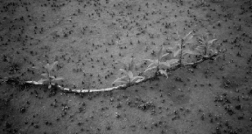
(8) layering - lower branches are pressed into the soil by the weight of snow, woody
Debris, or moss and take root (boreal and northern conifers, esp. black spruce at its
northern limit, among others).
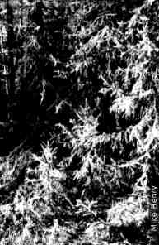

The primordium (the earliest bud stage) is composed of a group of cells and represents the initial stage in development of a plant organ (lateral bud). Lateral buds are those buds found along a shoot, not at the actively growing tip of the shoot (terminal bud). There are a number of pathways which the primordium can follow.

Figure 5.4 The Primordium (from: Forest Ecology by Barnes et al., 1998)
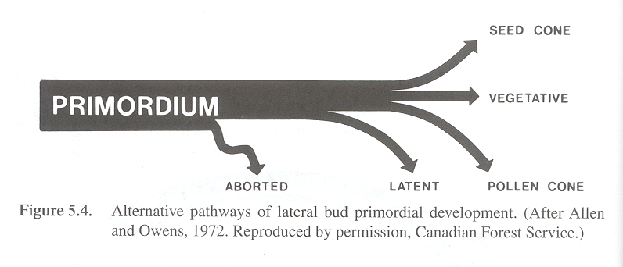
The five possible pathways for primordial bud development (Figure 5.4) include
(1) Aborted – bud degenerates & leaves no trace
(2) Latent – forms bud scales and then stops
Latent buds may develop later if:
Terminal bud (location of main shoot growth) is removed (e.g., by
herbivory)
Loss of foliage due to frost, insects, etc. – new set of leaves
Develops (e.g., oaks)
In older age, they may just spontaneously sprout
Latent buds usually become vegetative buds rather than seed or pollen cones.
(3) Seed Cone, (4) Pollen Cone, or (5) Vegetative Bud
The ratio among these three pathways may change from year to year depending
upon internal nutrition and hormonal relations in shoot & tree (e.g.,
periodicity of cone production).

Lateral buds at the base of a young shoot tend to become pollen cones while those towards the tip of the shoot tend to become seed cones or vegetative shoots.

Trees must mature before they are able to produce their first seeds. This maturation time varies with species. For example, a lodgepole pine may produce its first seeds within 10-20 years, while a Douglas fir typically takes 20-40 years to produce its first seed crop. Ponderosa pines, spruces and many firs take 40-60 years before producing their first seeds. Additionally, cones are not produced annually (think of how much energy it takes to make a cone!). Years with exceptionally high production are known as mast-seeding years, and are usually followed by one or more years of decreased production. Mast refers to the fruits of species in which this is prevalent (beechnuts, acorns, chestnuts, and even Douglas fir). Mast-seeding is thought to be an anti-predator adaptation (think of all the squirrels on campus!), by producing more seed than can be consumed.

Cone Crop Periodicity
1-2 years Lodgepole pine, willows, Populus
2-3 years subalpine fir, Engelmann spruce, Western hemlock, Quercus
3-5 years Western larch, western red cedar
3-10 years Ponderosa pine, Douglas fir

The best seed producers (not surprisingly) are dominant trees with large exposed crowns, vigorous growth, and of medium age.
Table 5.1 Regenerative strategies of widespread occurrence in woody plants. (from: Forest Ecology by Barnes et al., 1998)
Regeneration Method |  | Functional Characteristics | Conditions under which strategy appears to enjoy a selective advantage | Examples
Vegetative: clone maintenance or expansion | V | New vegetative shoots remaining attached to parent plant until well established | Productive or unproductive sites subject to low or high intensities of disturbance
active seed bank | B_{a} | Viable seeds that have no dormancy requirement; reside in seed bank less than a year | Sites with favorable weather or seasonally predictable disturbance by climatic or biotic factors
Dormant and persistent seed bank | B_{d} | Viable but dormant seeds present throughout the year; some persisting more than a year | Sites subjected to temporally unpredictable disturbance
Fire-induced opening of cones | F | Heat of fire opens cones where seeds are stored; seeds germinate immediately following favorable moisture and site conditions | Sites prone to relatively frequent, intense fires
Widely wind-dispersed seeds | W | Propagules numerous and exceedingly buoyant in air; widely dispersed and often of limited viability | Sites subjected to spatially unpredictable disturbance
Locally dispersed seeds | L | Propagules few and heavy; dispersed by gravity and animals; seed buried | Sites predictable in vicinity of parent plant
Persistent juveniles | B_{j} | Offspring derived from an independent propagule; seedling capable of long-term persistence in a juvenile state | Sites subjected to low intensities of disturbance
Source: Modified from Grime, 1988. Reprinted from p. 378 in Plant Evolutionary Biology by L.D. Gottlieb and S.K. Jain (eds.).
Figure 5.3 The 17-month reproductive cycle of Douglas fir. (from: Forest Ecology by Barnes et al.,
1998)
EMBED Photoshop.Image.6 \s 

