**How to use the ODC.**

An online course on how to participate in the Online Deliberative Center and use Wiki Technology.

This course is designed for anyone that wants to access and manipulate the data that is contained in the ODC.

The ODC is built upon a wiki platform meaning anyone can change the content on any page, much like on the ever popular webpage Wikipedia. The main difference between the ODC and Wikipedia is that access for making changes is limited to those given permission either through enrolment in a specific class or by being a distinguished contributor i.e. a Professor or TA. Also, content on the pages is monitored by people that study those specific areas.

In this online course you will learn how to:

1. Log in and create your contributors page
2. Edit your contributor’s page and upload images
3. Change your preferences and password
4. Reverse changes
5. Create an article page
6. Update Info boxes
7. Start a discussion

**Lesson 1: Login and create your contributors page**

**STEP 1: Logging in**

1. The URL to the ODC is: http://wiki.umt.edu/odccss
2. Your **username** is in the format: firstname.lastname
3. Your default **password** is: lastname

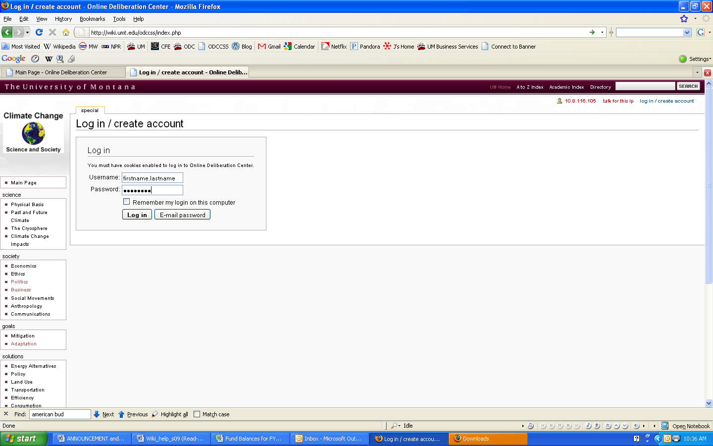

1. When you enter the URL you will be taken to the Main Page. Click on the link in the upper right corner that says: [log in / create account](http://wiki.umt.edu/odccss/index.php?title=Special:Userlogin&returnto=Main_Page).

**STEP 2: Creating your contributors page**

1. Once you are logged in, your name will appear (click on it to create your user page):

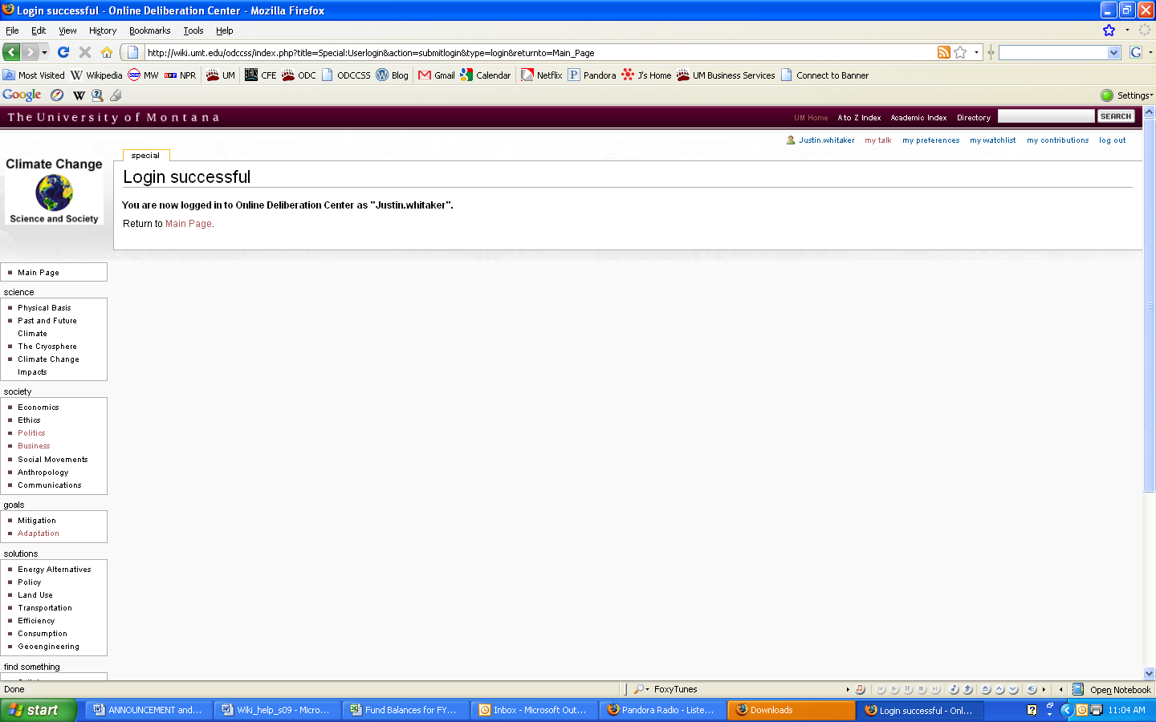

1. Click on edit this page to begin. 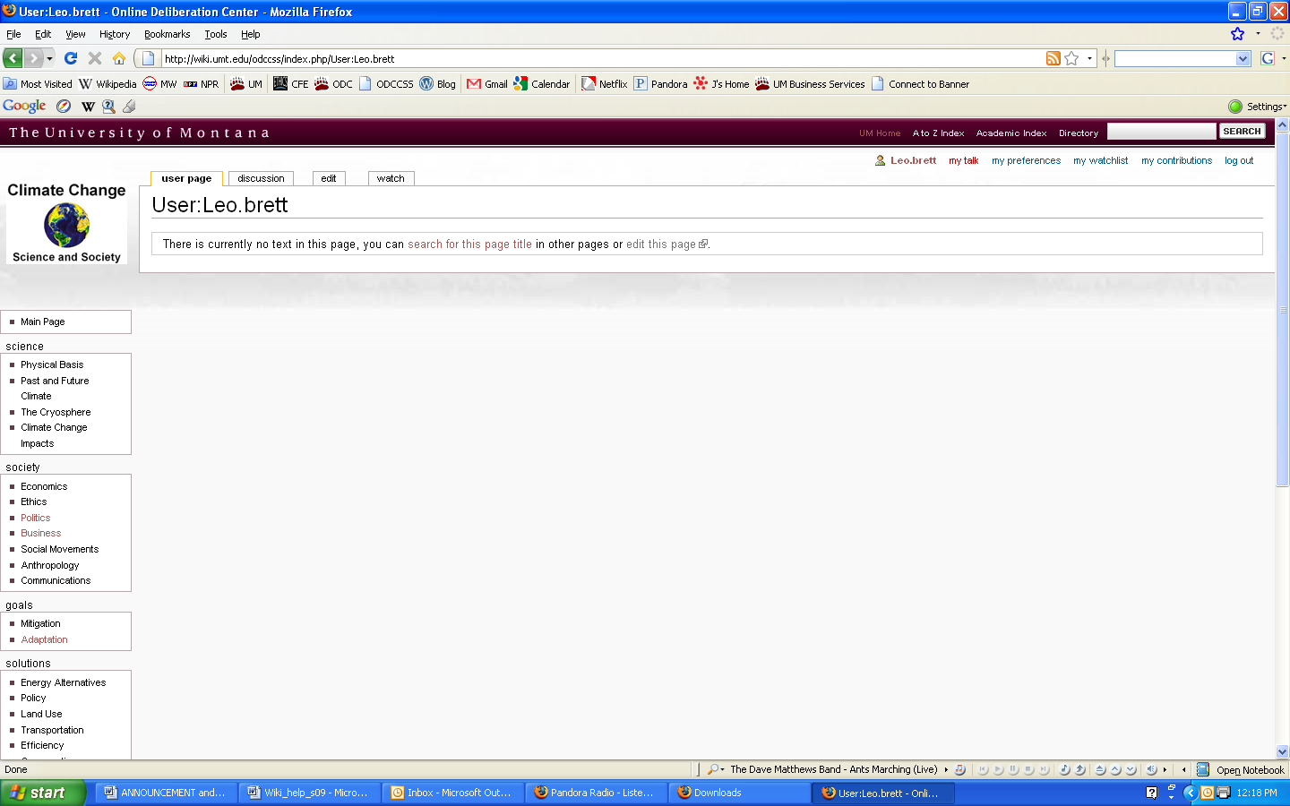
2. Include the following information.
   1. Name, major, year, hometown, general interests
   2. Interest in the Climate Change: Science and Society course and any background you have related to this topic
   3. Upload an image (see **Add Image** below in the next lesson)

To add information simply type in the white box. Use the text editor above the white box to format your entry.

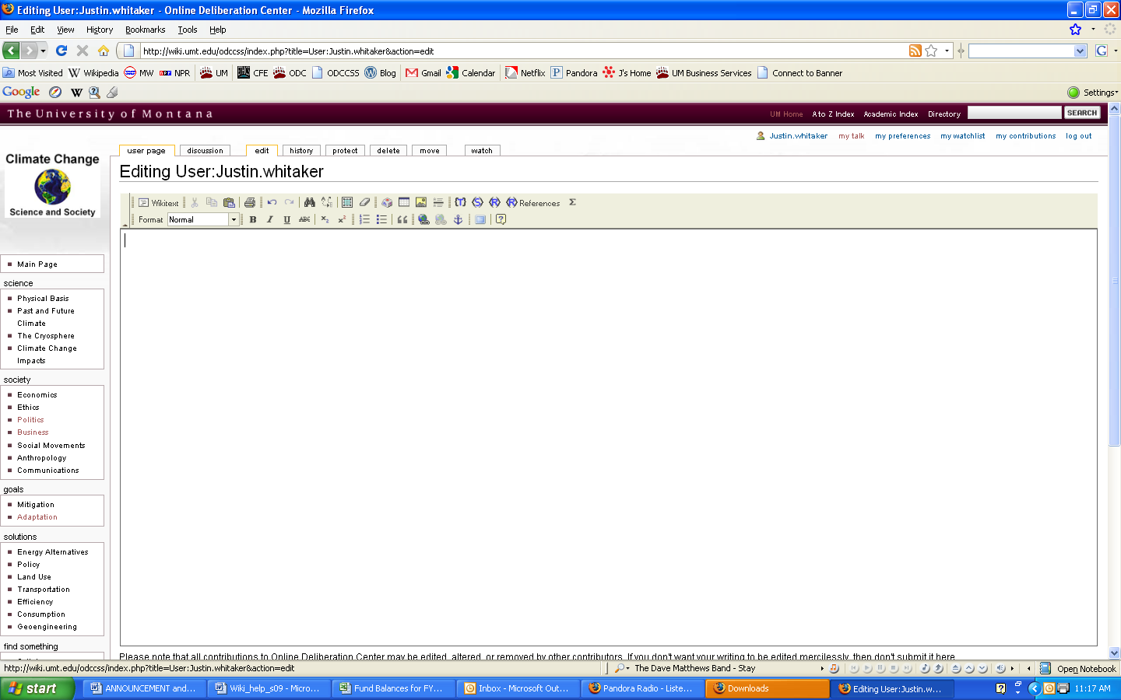

*Use this toolbar like you would a Word program. Explore it to see what you can and cannot do with it. See the bottom of this document for help in going beyond the toolbar.*

*Click here to create your user page.*

1. Click on the **Save Page** button on the bottom of the page
2. The changes you have made should now show on the screen
3. To edit your page from here on out you will have to click on the edit tab at the top of your page.

**Lesson 2: Edit your contributor’s page and upload images**

**Step 1: Upload an image.**

1. To upload image, go to the main page of the Wiki. In the Toolbox section, click [upload file](http://wiki.umt.edu/odccss/index.php/Special:Upload).

*The toolbox is at the bottom on the left.*

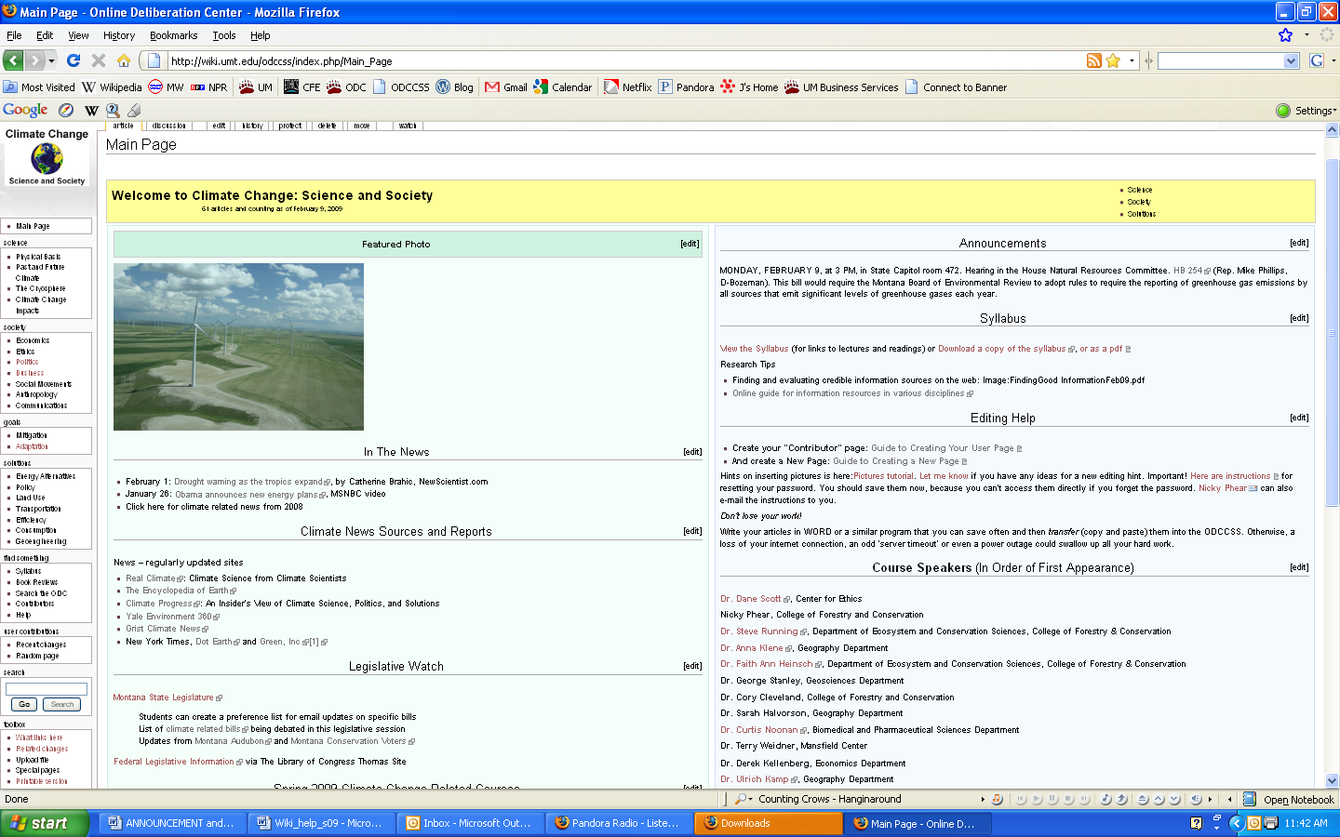



The above screen will appear:

1. Click the **Browse** button and find the image you want on your page.
2. Once you have selected your file, click the **Upload file** button. Your image is now ready to use on a page.
3. Copy or write down the name of your image(you will need this later)

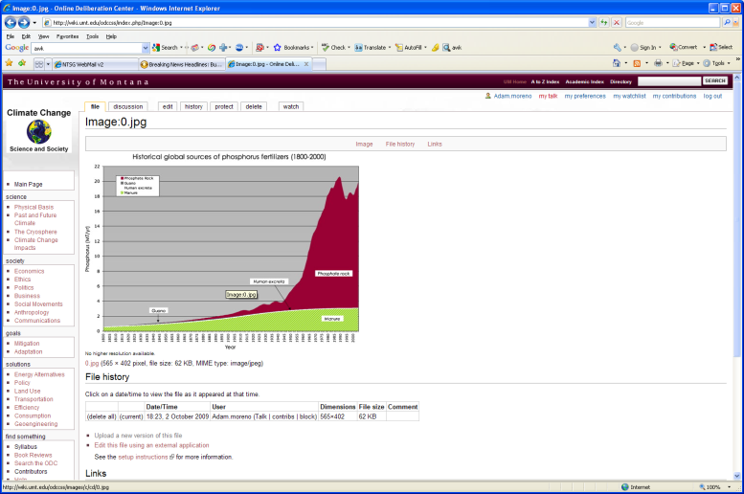

(**NOTE**: if your file is larger than 150 KB it will ask you if you want to ignore the warning a load the file anyway. Click Save file.)

**Step 2: Add the image to your page**

1. To add the image to an article, go to the article and click **edit** at the top of the page. Once
2. In the editing window, click on the button with the landscape. Note: if the editing window looks different than what is shown you can click on “Rich Editor” to change it.

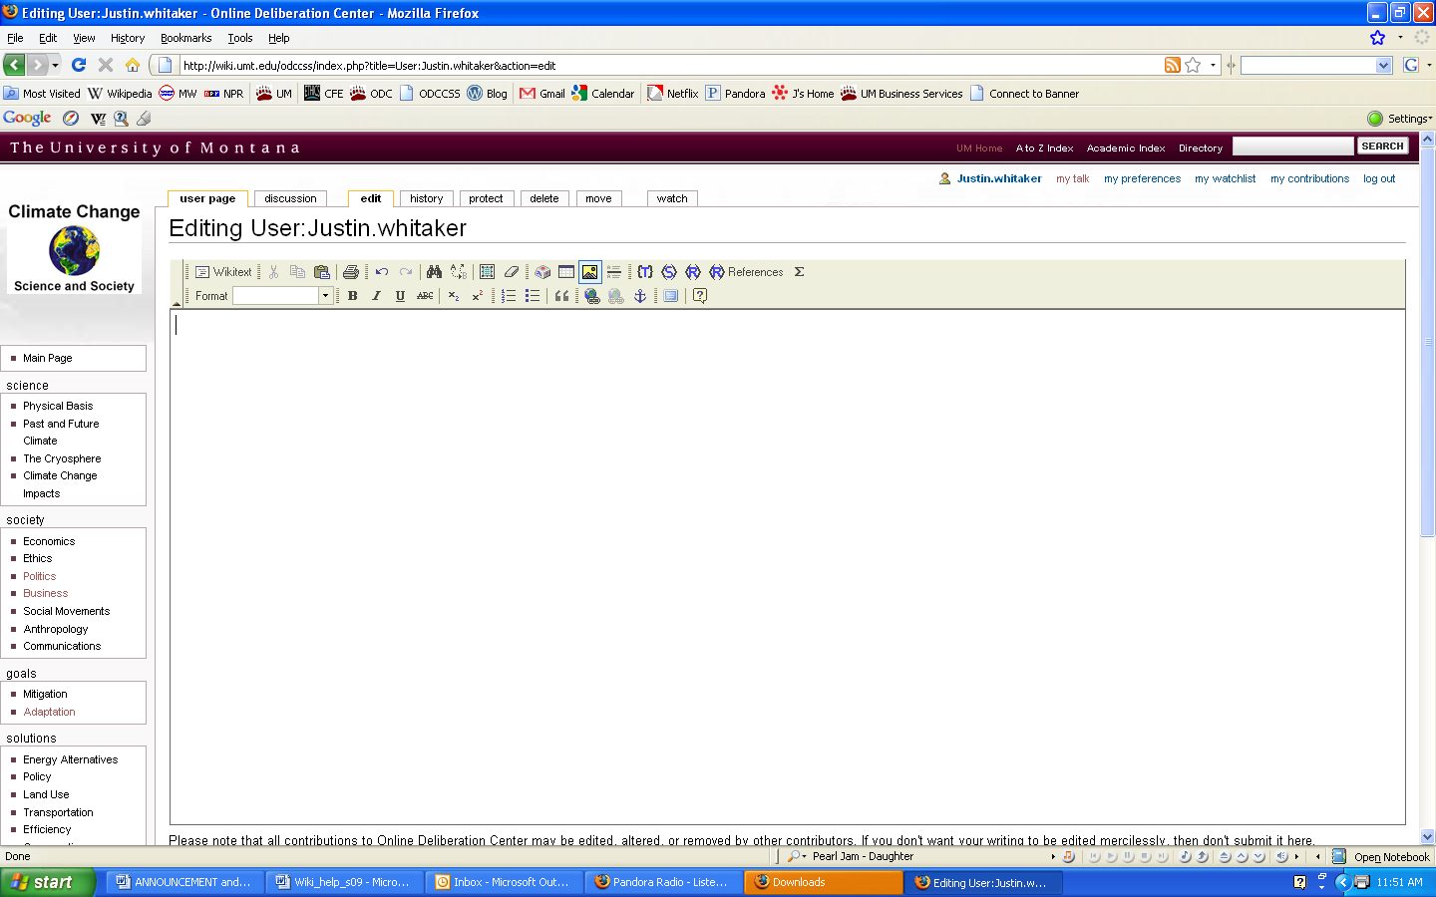

1. This will open a new window:

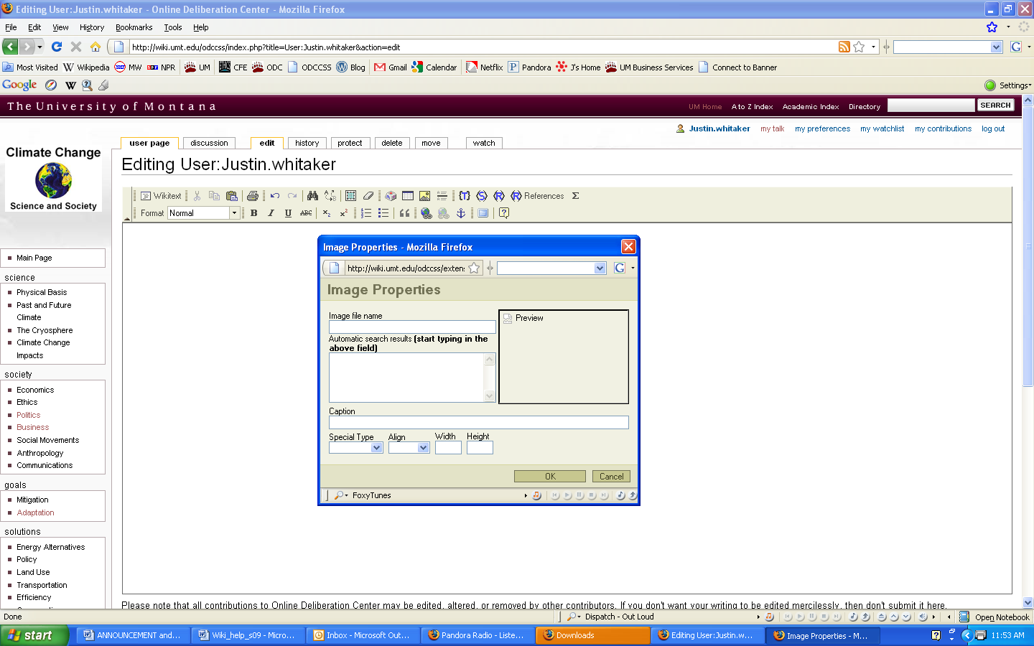

1. Select your image out of the list and click on it and a preview will appear

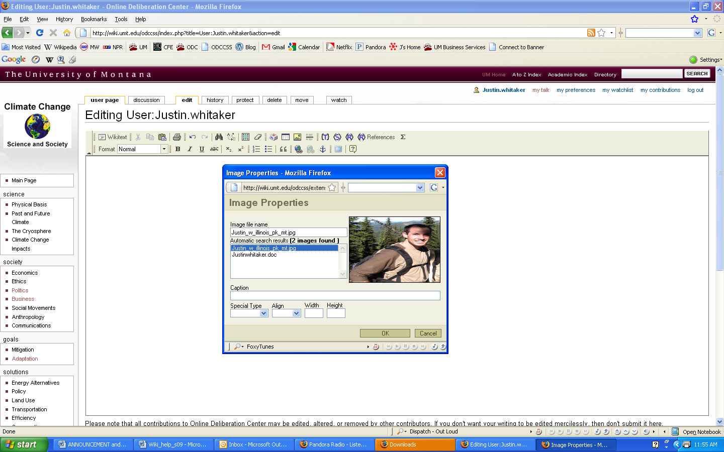

1. Add a caption describing the image. Try adjusting the Special Type, Alignment and so on to see how to make images fit into pages in different ways. Click OK to see the file in your page. To see how it will display, click Show Preview at the bottom of the editing page. Click OK.
2. From here you can change any of the text in the body of the document. Makes some changes and click save. You might need to click save a second time until your final page shows up again.

Note: You don’t have to use the Rich text editor if you don’t want. Just use this syntax [[Image:image_name|alignment|size(ex. 400px)|description]]

**Lesson 3: Change your preferences and password**

1. Click on My Preferences. Take a moment to familiarize yourself with options in this area. These include your E-mail address, password, and other options.

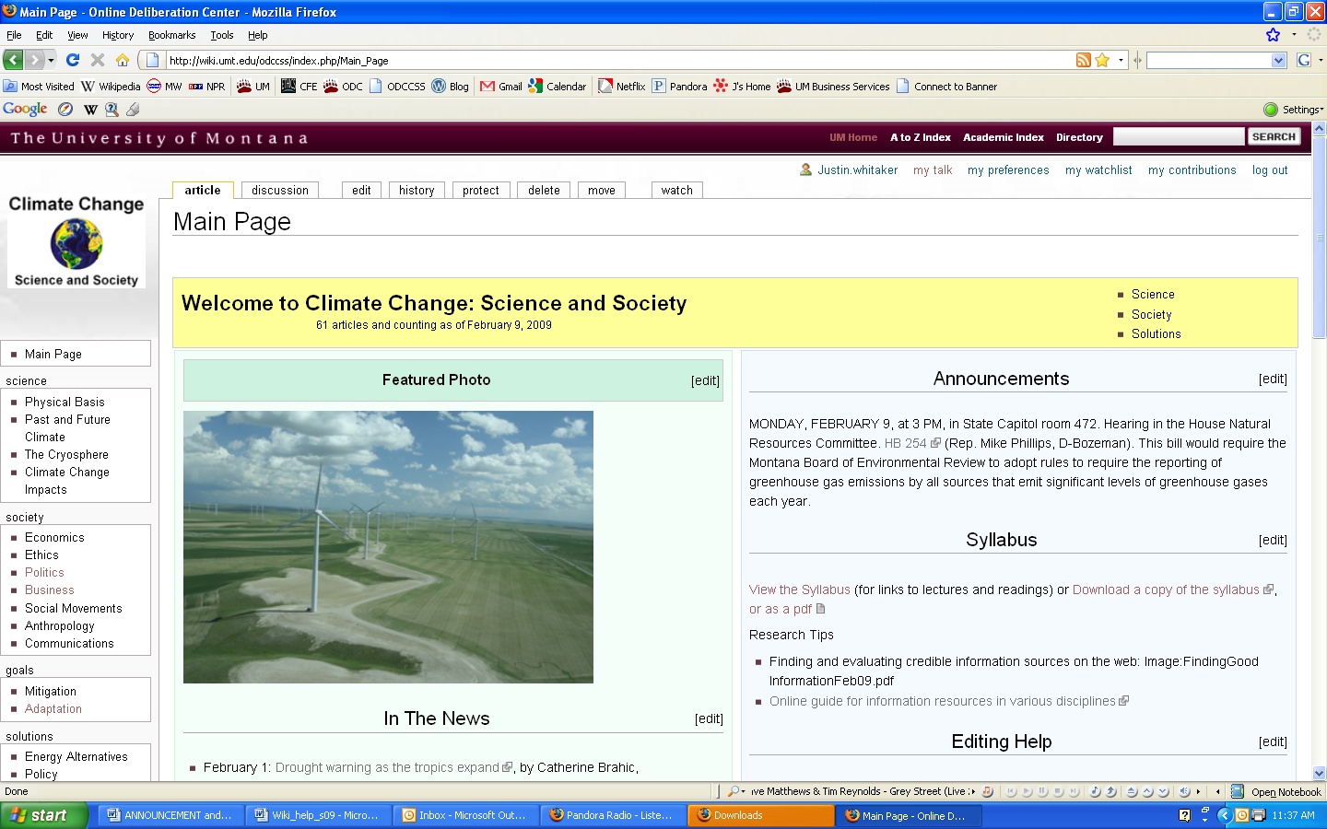

1. Be sure to update these **immediately**.

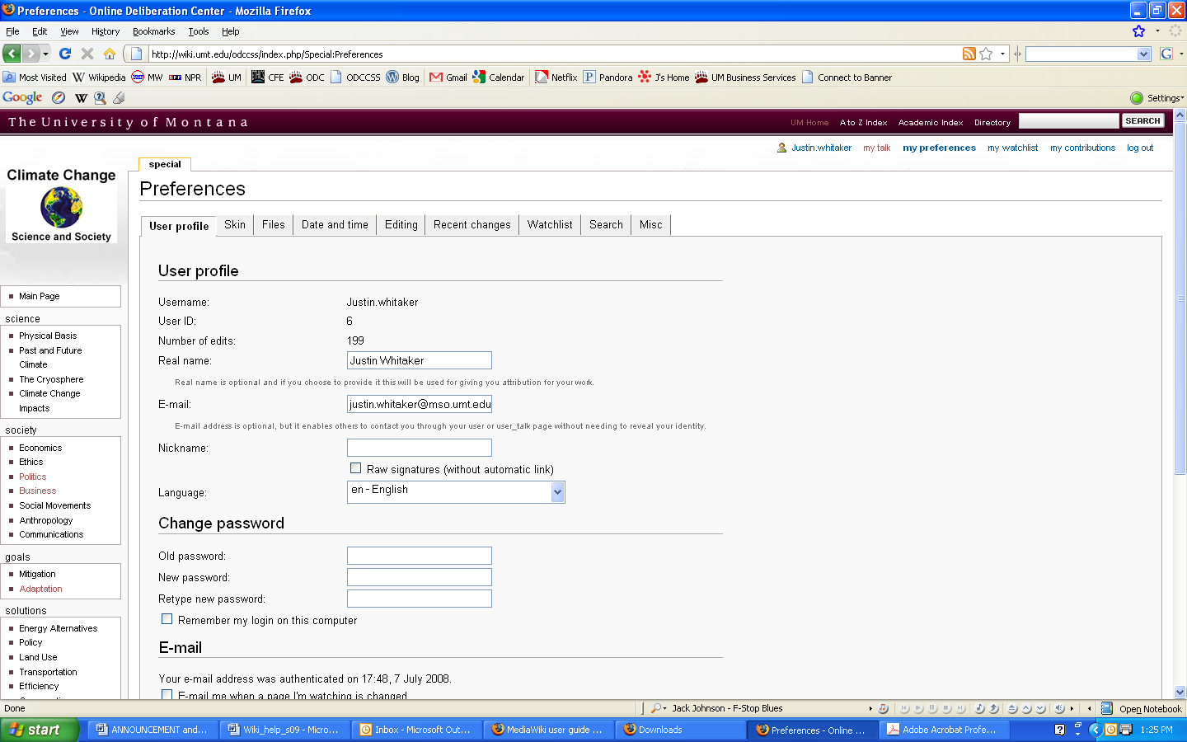**Lesson 4: Reverse Changes (using the history tab)**

1. Go back to your contributor’s page
2. Click on the history tab

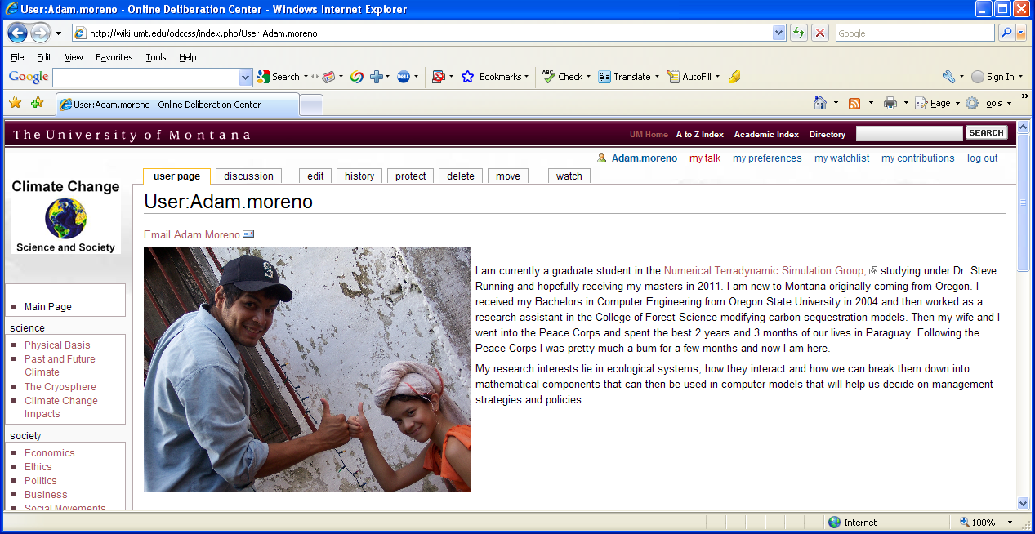

1. This page shows all of the changes that have been made to this page.

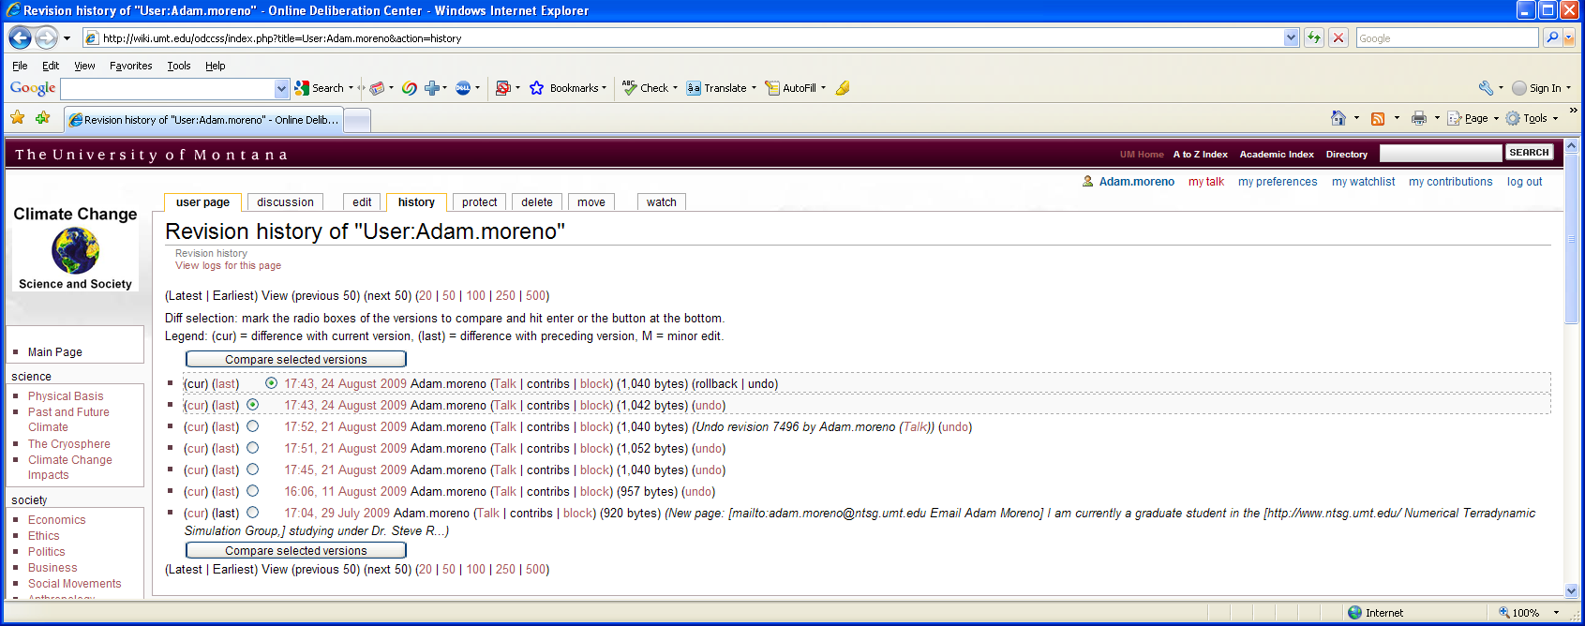

1. Click on undo at the end of the top line. This will undo the latest change you made to your page.
2. This page shows the difference between what your current page looks like and what it looked like before you made a change. What lies in the green bar is the difference between the two pages.

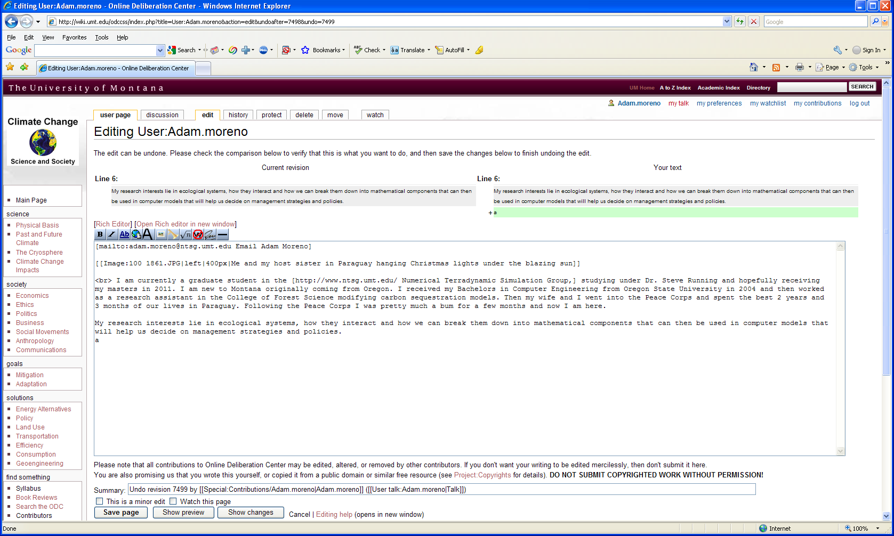

1. Click the save button and you will revert back to the previous appearance of your page.
2. Now do it all again to revert back to how your page was before you started Lesson 4

**Lesson 5: Create an article page**

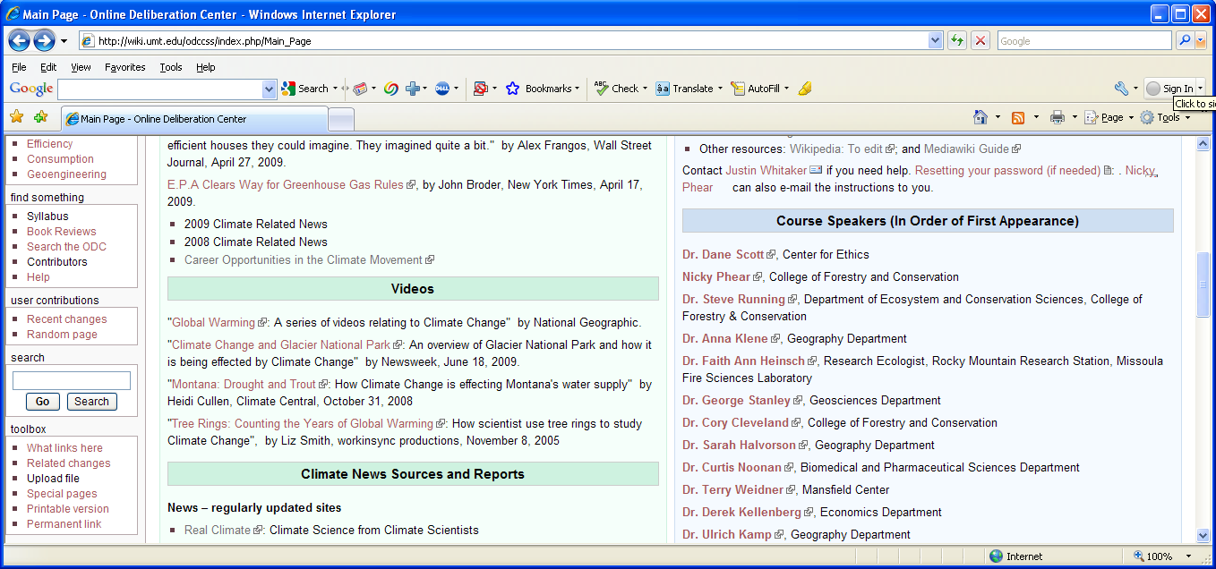

1. Search for an article
2. Type your search in the **search** box (lower left), click **Go.**
3. If the article exists, you can edit it by clicking on the **edit** tab.

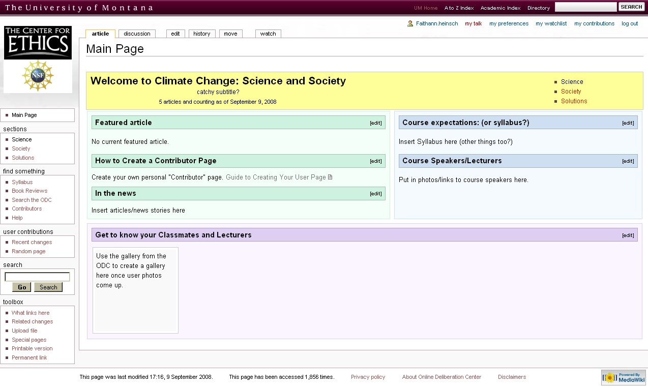

1. If it does not exist click **create this page**.
2. To add text, simply type the information in the edit box that you want on the page.
3. Make sure you choose **Save Page** when you are finished editing an article.
4. You should include an **edit summary** to describe what change you made.
5. 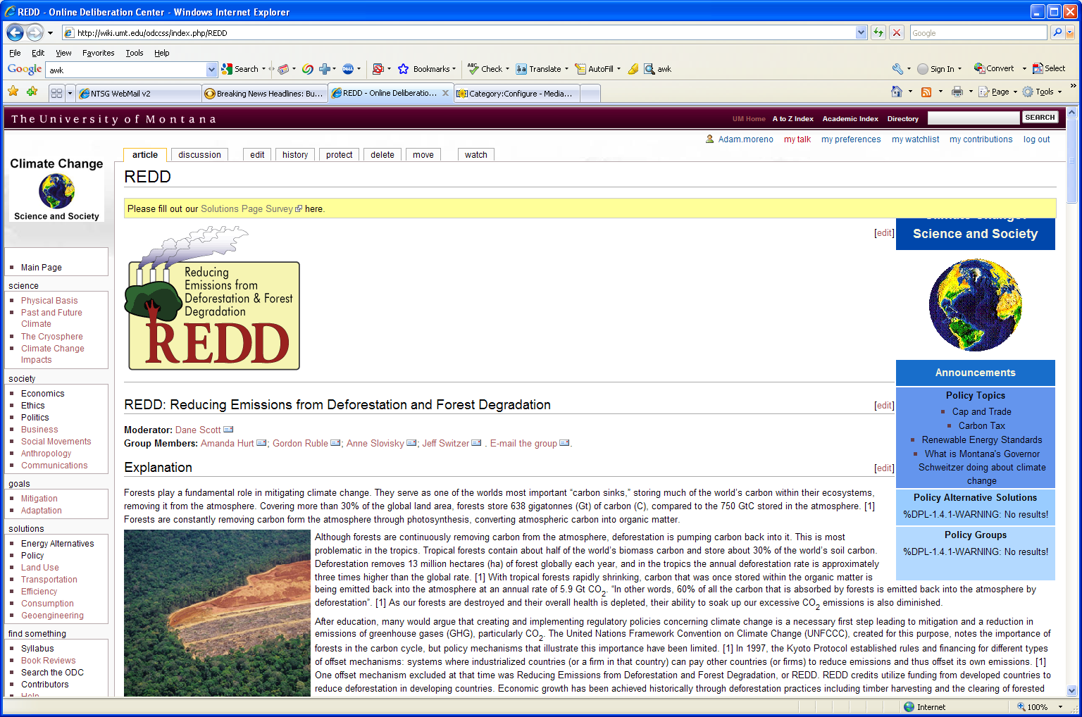Now click the section that you believe your article would best fit
6. Edit this page, click the ‘add link’ button and type in the title of your page
7. Like when you added the image click on your page in the box and press OK.

**Lesson 6: Update Info boxes**

1. Info boxes are the blue boxes on the right side of some pages and are used to help organize information within the Wiki.

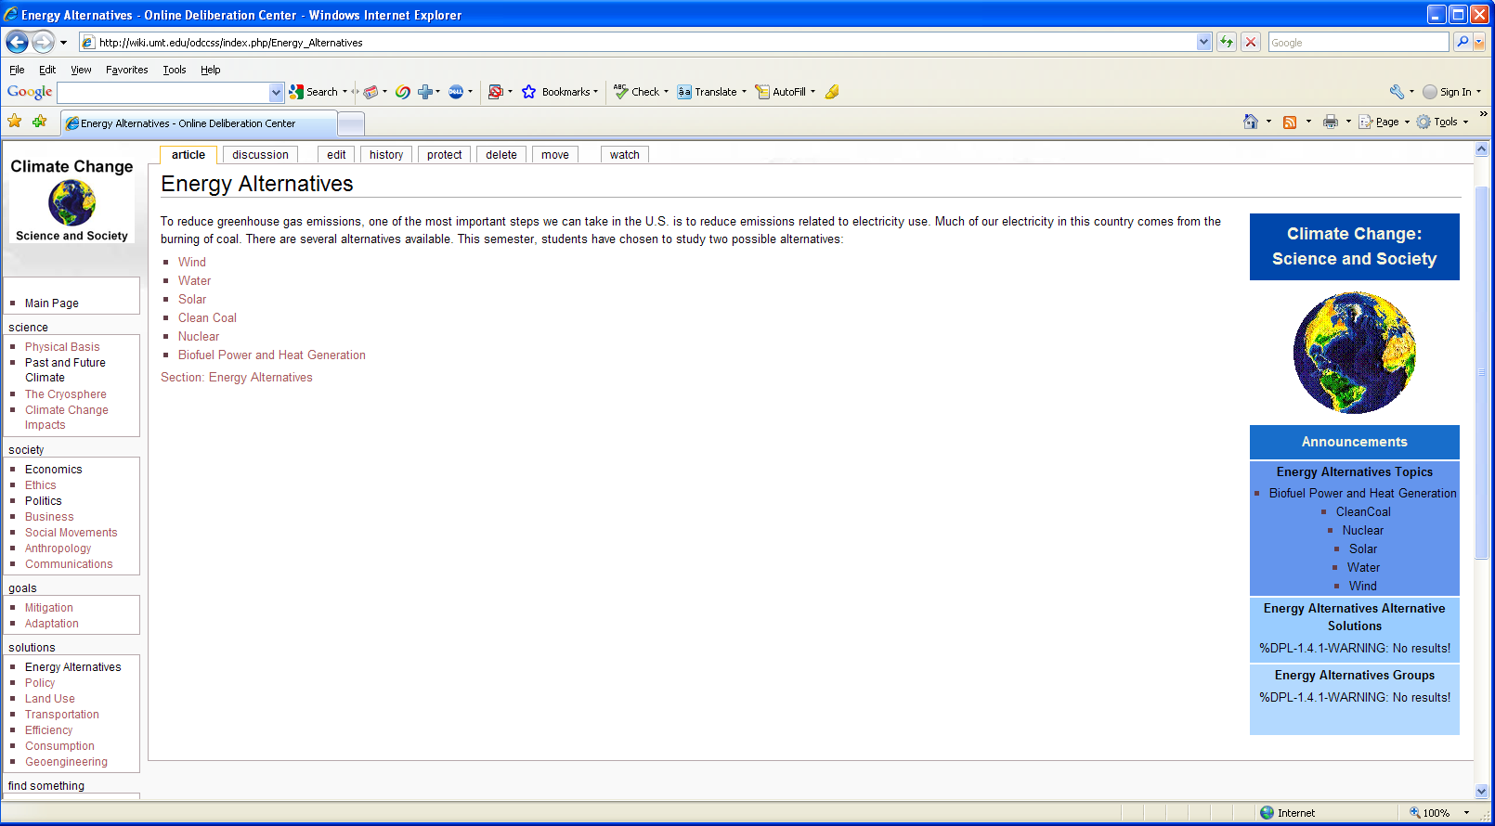

1. When you are editing your page you can place your page into a certain category. It will then appear in the info box under the appropriate heading. Use this syntax at the beginning of your editing window while rich text is disabled.

__NOTOC__ {{Infobox deliberation | Section = Name of Section }}

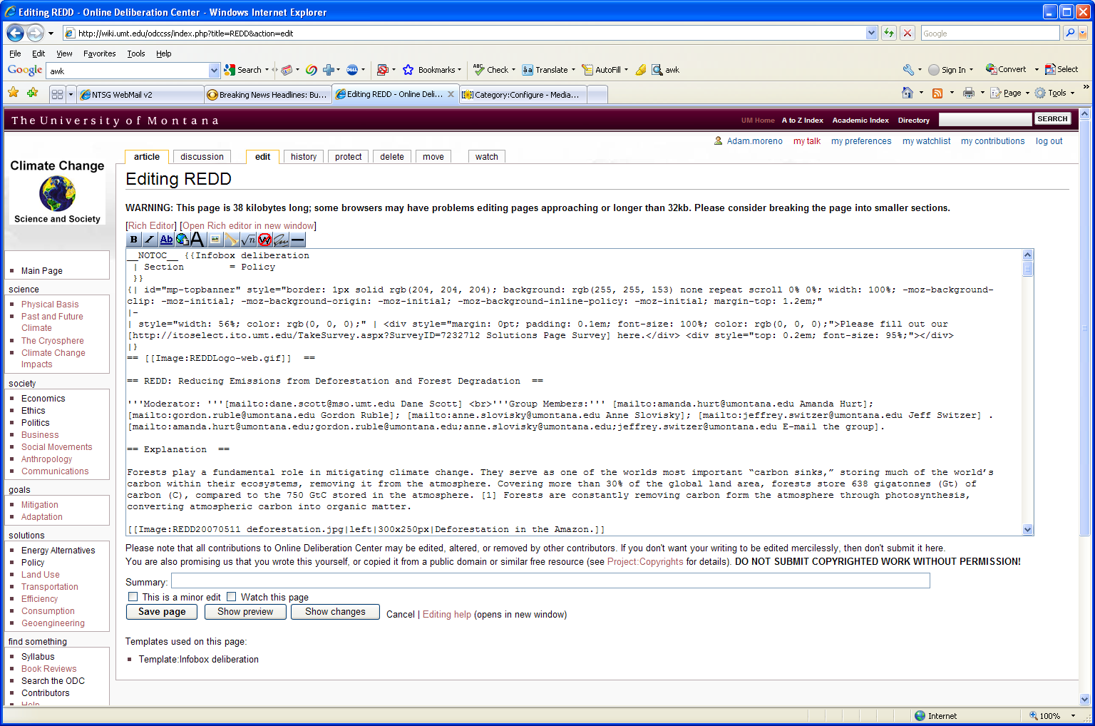

This page is in the Policy section.

1. Put this syntax at the end of your page

[[Category:Section]] [[Category:Subsection]]

Ex. Policy would be the Section, and Topics, Alternative

Solutions and Groups would be subsections.

**Lesson 7: Start a discussion**

1. The purpose of the discussion section of the ODC is to allow one to ask questions or add comments about anything pertaining to climate change.
2. Click the discussion tab while on the page on which you would like to comment.

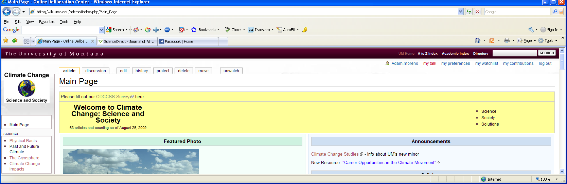

1. To create a new discussion click the “Start a new discussion.” Or to reply to an already created discussion go to the comment on which you want to reply and click the button “reply”